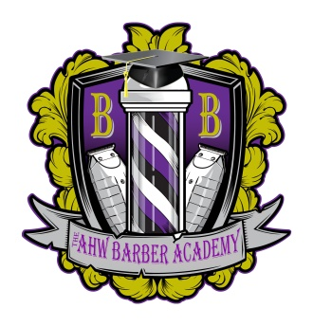
The AHW Barber Academy
3822 N 9th Ave
Pensacola, FL 32503
850-692-9298

PRE-ENROLLMENT CHECKLIST

Student Name
Program | Date

I have received written information concerning the following topics prior to signing my enrollment agreement:

☐ | School Catalog
☐ | School’s Graduation Rate
☐ | School’s Licensure Rate
☐ | School’s Job Placement Rate
☐ | Certification or Licensure Requirements
☐ | State-required Information
☐ | Pre-Requisites for Employment
☐ | Satisfactory Academic Progress Policy

Student Signature | Date

